First Parish in Cambridge
Annual Congregational Business Meeting
June 2, 2019

Members of the congregation are notified that the annual congregational business meeting of First Parish in Cambridge will be held June 2, 2019, at 12 noon in the Meetinghouse.

Included in the agenda:

Election of governing board officers and members
Plans for the 2019 - 2020 church year
The Vision of Ministry and plans to realize it
Programs and staffing
Preserving our historic building
Approval of the 2019-20 budget
Reauthorization of social justice teams

A light lunch will be available before the meeting and childcare will be provided during the meeting.

All voting members in good standing can check in at the start of the meeting to receive voting cards. Voting members must have officially joined First Parish and have made a financial contribution of record within 12 months of the meeting. If you are unsure of your status, contact Carol Lewis or call 617-876-7772 by May 25. Only voting members will receive voting cards.

Handouts and other information related to the agenda can be found in the website: http://www.firstparishcambridge.org/meeting. Please review this information before the meeting.

Our congregation is a democracy, which depends on each member’s voice and vote. Please join us on June 2.

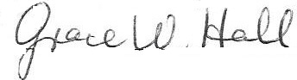

Rashid Shaikh Grace Hall
Governing Board Chair Governing Board Clerk

