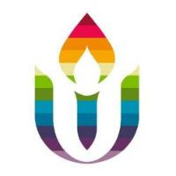
First Parish in Cambridge
Social Justice News
September 21, 2020
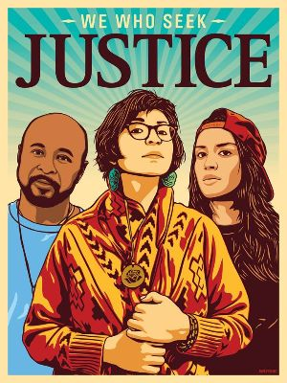

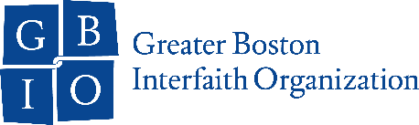
GBIO Racial Justice Meeting Sept. 24 6PM on Zoom.
Thank you to all First Parish members who have participated in Greater Boston Interfaith Organization meetings and actions. Most recently many of you helped support GBIO's racial justice agenda on police reform, decarceration, healthcare and housing by attending virtual meetings with your state legislator in July.
Please join us for a virtual GBIO Meeting on Thursday, Sept 24 via Zoom from 6PM-7:40PM: “GBIO on the Road to Racial Justice.” This gathering will provide an important opportunity to follow up on the critical legislative work that we began. We will also share some exciting updates about GBIO’s refounding efforts to expand membership, centering new institutions that serve communities of color and underrepresented groups in our network.
Thank you for your continued commitment to racial justice and we hope to see you there!
Marcia Hams, Elizabeth Kline, Cassie White and Sharon deVos for the First Parish Cambridge GBIO Team
Please RSVP at THIS LINK to join us.

Support UUs of Color: Expanding DRUUMM's Faith Formation
Diverse and Revolutionary UU Multicultural Ministries (DRUUMM) is a national Unitarian Universalist People of Color Ministry and anti-racist collective bringing lay leaders and religious professionals together to overcome racism through resistance and transform Unitarian Universalism through our multicultural experiences. Our ministry has grown substantially and we are organizing events to engage more deeply and trainings to build more intentionally in response to community needs. First Parish in Cambridge has benefited from these opportunities, including the September 19 New England Regional Caucus with six participants from our congregation. We welcome donations in support of expanding our local and regional program activities with funds going to support honorarium for guest speakers and facilitators.
https://faithify.org/projects/expanding-druumms-faith-formation/
Please contact the Racial Equity Team for more information or with any general questions at racialequity@firstparishcambridge.org.
The Environmental Justice Team invites you to participate in Climate Preparedness Week – September 24-30. The theme this year is "Social Resilience is Climate Resilience.” Communities Responding to Extreme Weather (CREW) is sponsoring a series of virtual events. This year the events will be focused on the intersections of climate resilience, racial justice and social resilience. You can join webinars on the role of social infrastructure in climate resilience; mapping which Boston neighborhoods are most vulnerable to climate change; the economics of climate change; organizing community “repair” events to combat our throwaway culture; resilient agriculture; and the links between racial justice and environmental justice. To learn more and to register for webinars you are interested in, go to climate week events. Registration is free.
Action Alerts from Beyond Borders - Sin Fronteras
It's important that we pass the Safe Communities Act (SCA) this legislative session for the safety of immigrant families in Massachusetts. The SCA Coalition is gearing up for a fall campaign, and needs your help to get the bill to a floor vote this session. The best way to do that is to secure commitments for a “yes” vote from a majority of state legislators.
One way to help is to join a phone banking session to help generate constituent phone calls to legislators. Each session will begin with a short training, followed by making calls, and then a debrief. Volunteers will reach out to constituents in key districts and ask them to call their state representative and advocate for the Safe Communities Act. Technical support will be on hand and you'll be provided with everything you need.
You can sign up to help here through UU Mass Action, or sign up for a session directly at one of the links below.
Monday, 9/21, 5:00-8:00PM –
Register here: bit.ly/SafeCommunities_921
Thursday, 9/24, 5:00-8:00PM -
Register here: bit.ly/SafeCommunities_924
Tuesday, 9/29, 5:00-8:00PM -
Register here: http://bit.ly/SafeCommunities_929
Thursday, 10/1, 5:00-8:00PM -
Register here: http://bit.ly/SafeCommunities_101

Let Our Families Drive!
March and rally in support of licenses for all
September 26, 2pm
After months of organizing district meetings, actions, and demanding for the passage of the Work & Family Mobility Act, thousands of black and brown immigrant families continue to live in fear of ICE detention for being stopped for a traffic violation and many are being deported. All families deserve the right to move freely in our state and live in dignity. On September 26th there will be a march and rally to hold legislators accountable to support expanding access to driver’s licenses across the Commonwealth.
WHEN: Saturday, September 26
TIME: 2:00 PM
WHERE: Meet us outside the Registry of Motor Vehicles (RMV) located at 136 Blackstone St, Boston (by the Haymarket T Station).
See here for more details.

This week’s educational suggestion from the Middle East Education Group is a presentation sponsored by Massachusetts Peace Action (MAPA) that took place on July 21 2020. It is titled “Prospects for Peace in Afghanistan”. Featured speaker is with Matthew Hoh, who is a former Marine Corps Captain and is also a veteran of the U.S. Defense Department and the U.S. State Department, where he was a Foreign Service officer in Afghanistan. Here is a link to the presentation.

