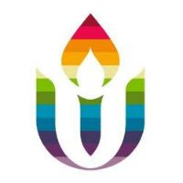
First Parish in Cambridge
Social Justice News
October 5, 2020
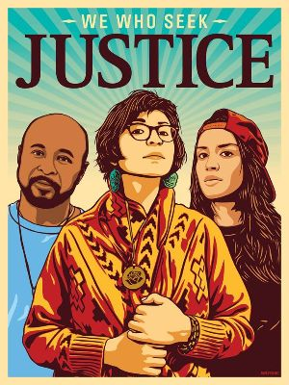
Be Part of UUtheVote’s Campaign to Vote Love, Defeat Hate
We hope you watched the beautiful and inspiring service last Sunday on UUtheVote—you can find it at this link. We heard inspiring messages and music to help us put our UU values and faith into action. We also saw many familiar faces---former FPC staff person, Rev. Mykal Slack, former intern Rev. Sana Saeed, and UUA President and FPC member, Rev. Susan Frederick-Gray
.
Unitarian Universalists are answering the call of our faith, building powerful partnerships to mobilize our faith communities and partnering with front line organizations whose base are black, brown, marginalized folks who want our help turning out those who get targeted for voter suppression. When you make calls or texts with UUs across the country, you will be helping these local groups in Ohio, Florida, MI and PA. And your electoral organizing will be part of a growing justice movement for now and the long haul. If you are already doing electoral work with other organizations, that is your contribution to putting UU values into action.
You can take part in the upcoming UUtheVote “Harvest the Power” week Oct. 21-27. To find out more and sign up, go to https://www.uuthevote.org/harvest-the-power-week-of-action/ For more on UUtheVote go to www.uuthevote.org.
To share your experiences you can go to the First Parish Facebook page or UUtheVote Facebook Group, https://www.facebook.com/groups/UUTHEVOTE.
If you want help or to find a FPC “buddy” to work with on UUtheVote or other actions, contact us.
Social Justice Council chairs Marcia Hams or Rosalie Anders.
The Social Justice Council calls your attention to a free workshop on October 10: “Storytelling for Advocacy”.
Here is a FREE workshop that should be of interest to social justice advocates who want to learn how to integrate storytelling into their work. It is sponsored by Unitarian Universalists for Social Justice (www.uusj.org ), a UU-related organization in Washington DC.
Click here for the Storytelling for Advocacy Flyer.
Date: Saturday, October 10, 2020 Time: 1-4pmET RSVP: Register HERE to get Zoom details.
Contact: Paulette DeMers; For questions email Advocacy@uusj.org
Natalie Miller-Moore will be the workshop “Storytelling Coach”. Natalie is the owner and CEO of “Moore than Words” providing strategic communications consulting services in areas including healthcare, politics, and marketing. She is a member of the Williamsburg UU Church, Virginia.

Please join the United American Indians of New England for a peaceful protest on Saturday October 10 at noon outside Park Street Station. We will be masked and physically distanced during the rally and march.
Your physical presence as white allies is important to support UAINE's demand that the city of Boston honors Indigenous Peoples Day and commits to not returning the Columbus statue to Boston's waterfront. Masks up, Columbus down! Here is the link.
For those who have not protested since the 1960s, this is your chance to stand against the white supremacy culture, and to experience the spiritual challenge of protesting peacefully in today's polarized world. The UAINE's peaceful actions typically attract would-be disruptors. Your witness and support mean a lot, particularly at the waterfront park at the end of the march.
Nina Lytton particularly encourages First Parish congregants to turn out as a group, hopefully wearing your Side with Love gear. Contact Nina Lytton with any questions.
Environmental Justice Team News
We ask that you please urge your legislator to pass the Mass. Pollinator Protection Act (H.763) which will ban consumer use of pollinator-killing neonic pesticides. Click here to send a quick message to your state legislators.
Two climate bills finally passed the MA house in late July and are in a Climate Conference Committee to reconcile the Senate and House bills. Please let your reps and senators know that you’d like the bills to include:
- H4933’s definitions of Environmental Justice Principles and Environmental Communities;
- Reject the expanded definition of non-carbon emitting sources now in H4933. Municipal Light Plants should not be allowed to include more biomass, landfill methane gas, trash, anaerobic digestion and wood as in the House’s proposed new greenhouse gas emissions standard. They are not renewable energy sources.
If you want to dig deeper, here is a helpful slide show from Fred Hewett of 350.
You can find your reps and senators here.
Members of First Parish are invited by Old Cambridge Baptist Church (OCBC) to A Ranked Choice Voting Conversation, Tuesday October 6, at 6:30 p.m. with Reverend Vernon K. Walker. Come learn about the social justice implications of this ballot initiative. Rev. Walker is the current Program Manager of Communities Responding to Extreme Weather (CREW) and Public Policy Director of the Young Democrats of MA and a campaign consultant for Ranked Choice Voting campaign. Here is the link to join.

The Middle East Education Group is letting you know about an interesting virtual event on Sunday October 11 at noon. It is being offered by the Palestine Museum US in Connecticut. Here is their invitation.
Virtual Artist Talks - Amal Ziad Kaawash
Please join us for a new episode of virtual Artist Talks featuring Palestinian visual artist, vocalist and songwriter, Amal Kaawash on Sunday October 11, at 12:00 Noon US EST; 7:00 PM Palestine Time. Amal will talk about her life growing up in a Palestinian refugee camp in Lebanon, her art and musical careers, a selection of which will be presented during the program.
Please click here to register for this event.

