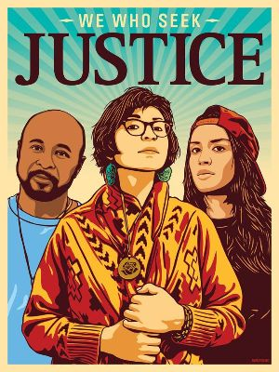
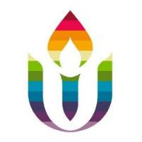
First Parish in Cambridge
Social Justice News
October 19, 2020

400 years after Pilgrim colonization,
support the 51st National Day of Mourning
Join other Unitarian Universalists in contributing financial and other support for this historic 51st Day of Mourning, November 26, organized by the United American Indians of New England. This year, in the midst of the pandemic, UAINE also seeks to raise funds to livestream the event so people across the country can participate and learn. First Parish will contribute our November plate offering to this effort, but your individual contributions now would be very helpful. (see below for gofundme link).
UAINE’s important work also includes leading efforts in Massachusetts to pass three important Indigenous rights bills: change the state flag and seal, ban Native mascots in public schools, and protect Native heritage. Time is running out for these bills to get a full vote by the MA House and Senate. See UAINE’s Facebook page to contact your legislators.

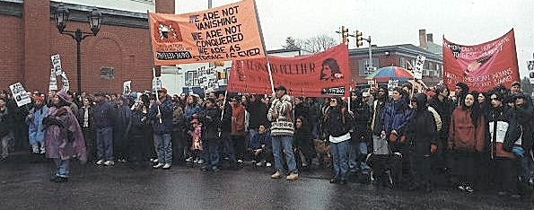
National Day of Mourning
Since 1970, Native Americans and our supporters have gathered at noon on Cole's Hill in Plymouth to commemorate a National Day of Mourning on the US thanksgiving holiday. Many Native Americans do not celebrate the arrival of the Pilgrims and other European settlers. Thanksgiving day is a reminder of the genocide of millions of Native people, the theft of Native lands, and the relentless assault on Native culture. Participants in National Day of Mourning honor Native ancestors and the struggles of Native peoples to survive today. It is a day of remembrance and spiritual connection as well as a protest of the racism and oppression which Native Americans continue to experience.

51st National Day of Mourning: November 26, 2020
12:00 Noon
Coles Hill, Plymouth, MA
Details to be announced: please continue to check this page (uaine.org) and especially our Facebook group (ask to join!) for updates.
DONATIONS:
Monetary donations are gratefully accepted to help defray the costs of the day. Go to gofundme to make a donation. Every donation is greatly appreciated!
---First Parish Social Justice Council and Racial Equity Team
Environmental Justice Team News
The MA House and Senate both passed climate bills in late July. A Climate Conference Committee met in September and October to reconcile these bills. The Committee has suspended its work, but will start up again in early November after the election. The legislative session has been extended until December 31, because of COVID-19. The EJ Team would like to invite YOU to join us in November and December in making an urgent push with our state Representatives and Senators to lobby the Climate Conference Committee to agree on those provisions most beneficial for Environmental Justice and implementing carbon emissions reductions! We will provide more information in the November 6th Social Justice Newsletter.
In the meantime, you can learn more about the House and Senate climate bills here: https://bit.ly/legislides
Webinar of interest
Our Goal of World Community: The United Nations at 75
Thursday, October 22, 2020 | 6:00 PM - 7:30 PM Eastern.
Rev. Dr. Susan Frederick-Gray, President, Unitarian Universalist Association, is one of the featured speakers.
This year, the United Nations is celebrating its 75th birthday, and the Unitarian Universalist Association Office at the UN, in collaboration with the Canadian Unitarian Council, will be commemorating that anniversary with a special virtual event co-sponsored by the NGO Committee on Human Rights: "Our Goal of World Community: The United Nations at 75." In the current moment of simultaneous global political, social, economic, health, and climate crises, continued involvement with and investment in international cooperation could not be more critical. During this event we'll talk about how Unitarian Universalists can make our mark for global justice. Click HERE to register in advance for this meeting.

Join with other First Parish members taking part in national UUtheVote phone banks available on multiple days ---go to www.uuthevote.org to register. A special “Harvest the Power” week will be held Oct. 21-27, with two days for phone banking with UUs nationally in collaboration with local state partners:
Wisconsin: Wed. Oct. 21, from 7-9 pm EST
Philadelphia: Sat. Oct. 24 from 1-4 pm EST.
To sign up, go to https://www.uuthevote.org/harvest-the-power-week-of-action/.
UUMassAction is also hosting statewide UUtheVote/Reclaim Our Vote phone banks to call key swing states on Wed. Oct. 14, 21 and 28. 5-7pm EST. To sign up and get trained for these, click here.
Connect with others at FPC. Let us know if you would like to be in contact with others at FPC who are participating in any of these phone banks. And if you are already doing election and voting rights activities with other organizations, thank you! We are all putting our UU values into action for the most critical election of our lifetimes.
Contact: Rashid Shaikh or Marcia Hams if you want to connect with other FPC UUtheVote volunteers.
The Middle East Education Group wants to inform you of a webinar notice from the Unitarian Universalist United Nations Office. The webinar addresses Islamophobia on a worldwide basis, including the intersection with racism.
Islamophobia and Race: What Are We Afraid Of?
Friday, October 23, 2020 | 10:00 AM - 11:30 AM Eastern
Sponsors: UUA International Resources: UU Office at the United Nations, NGO Committee on Human Rights, and the Burma Task Force.
Join us for a global conversation on faith-based discrimination and ethnic genocide. This discussion will explore the experiences of the Muslim community worldwide, while examining the intersectional ways in which Islamophobia and racism interact to perpetuate harmful preconceptions and prejudice. Speakers representing Myanmar, Sudan, Tibet, and the United States will reflect on their unique sociocultural identity and how Islamophobia continues to intricately impact multiple dimensions of their lives. Click HERE to register in advance.

UUMassAction
An important way that First Parish connects with UUs statewide to put our faith into action is through UUMassAction. Its statewide legislative campaigns currently are: The MA Indigenous agenda; Climate Action and Justice; Immigrant Justice; Stop Evictions/Foreclosure; Ending Solitary Confinement; and Economic Justice. It provides excellent resources for study and opportunities for action. See www.uumassaction.org and also sign up for the weekly newsletter.

