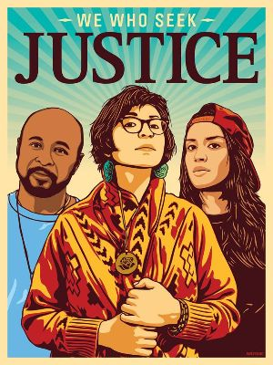
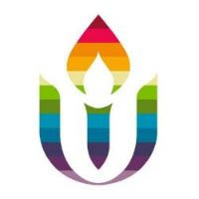
First Parish in Cambridge
Social Justice News
October 19, 2020

400 years after Pilgrim colonization,
support the 51st National Day of Mourning
Join other Unitarian Universalists in contributing financial and other support for this historic 51st Day of Mourning, November 26, organized by the United American Indians of New England. This year, in the midst of the pandemic, UAINE also seeks to raise funds to livestream the event so people across the country can participate and learn. First Parish will contribute our November plate offering to this effort, but your individual contributions now would be very helpful. (see below for gofundme link).
UAINE’s important work also includes leading efforts in Massachusetts to pass three important Indigenous rights bills: change the state flag and seal, ban Native mascots in public schools, and protect Native heritage. Time is running out for these bills to get a full vote by the MA House and Senate. See UAINE’s Facebook page to contact your legislators.

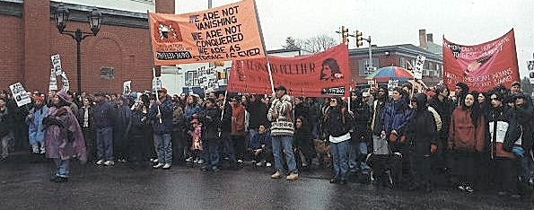
National Day of Mourning
Since 1970, Native Americans and our supporters have gathered at noon on Cole's Hill in Plymouth to commemorate a National Day of Mourning on the US thanksgiving holiday. Many Native Americans do not celebrate the arrival of the Pilgrims and other European settlers. Thanksgiving day is a reminder of the genocide of millions of Native people, the theft of Native lands, and the relentless assault on Native culture. Participants in National Day of Mourning honor Native ancestors and the struggles of Native peoples to survive today. It is a day of remembrance and spiritual connection as well as a protest of the racism and oppression which Native Americans continue to experience.

51st National Day of Mourning: November 26, 2020
12:00 Noon
Coles Hill, Plymouth, MA
Details to be announced: please continue to check this page (uaine.org) and especially our Facebook group (ask to join!) for updates.
DONATIONS:
Monetary donations are gratefully accepted to help defray the costs of the day. Go to gofundme to make a donation. Every donation is greatly appreciated!
---First Parish Social Justice Council and Racial Equity Team

Election and Post-Election Actions
Concern is mounting that our nation may be facing a grave threat—various ways to discredit the outcome or even a post-election coup attempt. There is widespread agreement that nonviolent protest may be needed to prevent the destruction of our democracy. Bipartisan groups are coming together to demand that all votes be counted and that the losing candidate not seize office or refuse to step down. An initial rally for these principles is planned for Wednesday, November 4, at 5:00 PM in front of the State House as part of a national mass action. Beyond that, other actions, if needed, will happen.
In this time of crisis, what are we called to do, as individuals and as part of our UU community? Go to UU the Vote (www.uuthevote.org) and Defend Out Elections (www.uuthevote.org/defend-our-elections) to learn about many other ways to take actions. And for post-election planning, we encourage you to watch this excellent video by clicking HERE.
ChooseDemocracy.us is having zoom trainings on nonviolent actions, on 10/26, 10/27, and 10/28.
Protectthevote.net has organized a pre-election hotline to make sure that voters know how to vote and to ensure that their votes are counted. They are looking for volunteers.
To share your ideas or with questions, please contact Peter Lowber or Rashid Shaikh.

UUMassAction
An important way that First Parish connects with UUs statewide to put our faith into action is through UUMassAction. Its statewide legislative campaigns currently are: The MA Indigenous agenda; Climate Action and Justice; Immigrant Justice; Stop Evictions/Foreclosure; Ending Solitary Confinement; and Economic Justice. It provides excellent resources for study and opportunities for action. See www.uumassaction.org and also sign up for the weekly newsletter.

