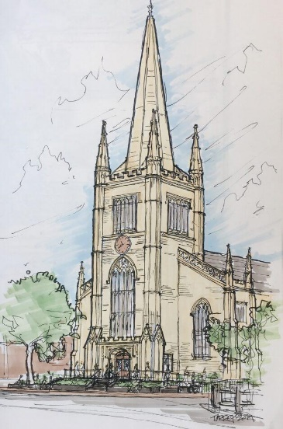
Development Ministry Team Report
May 26, 2021

The Development Ministry Team aids First Parish’s Governing Board, the congregation, and the staff to live our values. We raise funds, from all sources, to restore our historic building for current and future generations; pay a livable wage for staff; fund our programs that foster social and environmental justice; and provide a welcoming gathering place for community events and services. The Development Team reports to the Lead Minister. Current members of the team are Tod Hibbard (Chair), Cushing Giesey, Elizabeth Kline (Chair of Building Ministry Team), Carol Lewis (Director of Administration), Cade Murray (FPC Treasurer), Don Tucker, and Sylvia Wheeler.
Since the congregation voted in November to approve architect David Torrey’s design for the Massachusetts Avenue Entrance, Tower and Steeple Project, the Development Team has focused on raising the necessary $3.5 million. Working with our fundraising consultant, we have completed a feasibility study indicating how the funding can be raised. We envision a very broad, community-wide capital campaign, including foundation grants, funds from the City of Cambridge, gifts and grants from area businesses, special gifts from individuals, both in our congregation and in the wider Cambridge community, and funds from First Parish’s endowment. We are casting a very broad net.
We have already begun to pursue major grant funding for the project as well as historic tax credits and we have identified a number of promising opportunities. We believe for our campaign to be successful in raising money from others, we need to first show a substantial contribution from our own congregation; so, once the current annual stewardship drive concludes, we plan to invite members of the congregation who wish to do so to pledge special leadership gifts. Then, in September, we intend to ask a special meeting of the congregation to approve the use of endowment funds for this project. Based on these commitments from the congregation, we will then encourage special gifts from individuals, businesses and institutions in the wider community. Before we are done, we hope everyone who wants to support our project will have had the chance to do so. (If we neglect to ask anyone who wants to contribute, please let us know!)
The following are some of the highlights of the team’s activities to date:
- We have conducted research, reviewing fundraising materials and attending training sessions provided by the UUA and speaking with representatives from other churches that have carried out comparable projects to learn from their experience.
- We have hired a fundraising consultant who has worked with us to develop our case for support - why donors might be moved to support our project - including: our central location and iconic presence in Harvard Square; our role as a community gathering space and community organizing platform and the many services we provide; our prominent place in the history of Cambridge, of Unitarian Universalism, and of the country as a whole; our design for universal accessibility; our new green space, lighting, and the restoration of our distinctive architecture.
- Working with our consultant, we have identified and prioritized potential grant sources and prepared grant applications. We have already submitted a grant request to the Fund for Sacred Places and applied for Massachusetts Historical Tax Credits, both of which could generate a significant amounts.
- A project management timeline has been created with input from Torrey Architecture for the upcoming phases of the work.
- We formed a Special Gifts Group (Joanna Fink, Cushing Giesey, Gina LaRoche and Sylvia Wheeler) to pursue special gifts from members of the congregation as well as from individuals in the wider community.
- Following up on the approval of our proposed project by the Cambridge Historic Commission, we met with Charlie Sullivan, Executive Director, who is an enthusiastic supporter and who encouraged us to apply for CHC grant funding of $100,000 in grants this year and again next year.
- We met with Denise Jillson, Executive Director of the Harvard Square Business Association, who is also an enthusiastic supporter and who will help us with introductions to influential members of the business community.
- We are developing materials, including a brochure and articles for the press, setting forth our case for support.
- We are working with Carol Lewis to develop our databases, including Breeze, to support our fundraising effort.
- We are coordinating our efforts with the Building Ministry Team, Stewardship, the Investment Committee, and the Board.

The team will be making a brief presentation at the Annual Meeting on June 13 summarizing this work. Then, in the weeks following this meeting, we plan to hold a follow-up session via Zoom to encourage discussion and to answer questions from the congregation.

Respectfully submitted,
Tod Hibbard, Chair

